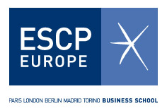

RCEM & CIBS Conference

‘Oil and Gas Modelling

Monday, 29th October 2012 – Energy Institute, London
www.rcem.eu/oilgas2012

About
The joint Conference of the Research Centre for Energy Management (RCEM) at ESCP Europe Business School and the Centre of International Business and Sustainability (CIBS) at London Metropolitan Business School (LMBS) will take place on October 29th from 14.00 to 17.30 at the Energy Institute in London.

The meeting aims to provide a forum for world-leading researchers and practitioners to exchange ideas and to present novel research results on the theory and modern practice of oil and gas modelling.

During the conference, CIBS and RCEM will also present a joint research programme which aims to advance the thinking and modelling frameworks for evidence-based energy policy and investment decisions, with a particular focus on oil and gas trading and security.

Programme
2.00pm -2.15pm: Welcome Coffee
2.15pm-2.30pm: Opening speech by Dr. Kostas Andriosopoulos, RCEM Director, ESCP Europe Business School
2.30pm-4.30pm: Speeches by:
Prof. Michael Jefferson, CIBS Professor; former Chief Economist of Shell and Deputy Secretary General of the World Energy Council
Prof. Rita D' Ecclesia, Director, PhD in International Economics and Finance; Sapienza University of Rome
Dr. Thierry Bros, Senior Energy Analyst, Societe Generale
Mr. John Mitchell, Associate Fellow, Chatham House
4.30pm-4.45pm: Closing speech by Dr. Vlasios Voudouris, CIBS Director, London Met Business School
4.45pm-5.30pm: Tea and Coffee

Registration
Admittance to the event is free, but there are limited places available. These will be reserved on a first-come, first-serve basis. Register online at www.rcem.eu/oilgas2012/registration.

Venue
The Conference will take place in the Lecture Theatre room at the Energy Institute:
61 New Cavendish Street, London W1G 7AR
For more information on how to get to the Energy Institute, please visit the following link: http://www.energyinst.org/about-us/where-to-find-us
Sponsors
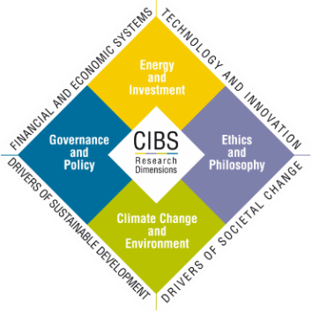
The event is jointly sponsored by the RCEM and CIBS.

Conference Secretariat

Kasia Wolenska

ESCP Europe Business School,
527 Finchley Road, London, NW3 7BG - UK
Tel: +44 (0)20 7443 8819
E-mail: kwolenska@escpeurope.eu

About the Research Centre for Energy Management (RCEM)
Bringing together the expertise of its faculty and its many external international associates, the objective of the RCEM at ESCP Europe Business School is to cooperate with, and possibly assist, key industry players to facilitate the integration of managerial and technological skills within the energy industry.
RCEM's Mission is to build a strong proactive partnership between energy corporations, government agencies and the academic community, in preparation for a new energy era. The results of RCEM's research will become available to the public through publications, workshops and conferences, educational programmes and other public outreach activities. Research at RCEM will be enhanced through direct cooperation with government agencies and academic and industry associates from across the globe.
Find out more at: www.rcem.eu

About ESCP Europe Business School
ESCP Europe Business School was founded in Paris in 1819 and since then has educated generations of leaders, contributing to the fine reputation it enjoys today.
With almost 200 years of experience, ESCP Europe’s standing in the sector is consistently recognised in the Financial Times’ league tables. In 2011, we were ranked the 12th best business school in Europe and 3rd in the UK. Our flagship Master in Management programme is currently positioned 2nd worldwide and 1st in the International Course Experience category.
We are proud to be one of the few institutions in the world to boast international accreditation by EQUIS, AACSB, AMBA and BAC.

About the CIBS
The Centre of International Business and Sustainability (CIBS) contributes a distinctive voice in the area of international business and sustainability by bringing together researchers from economics, statistics, policy analysis, strategy, energy and climate change to explore together what we call the 'Sustainability World'. As an interdisciplinary research centre at London Metropolitan Business School (LMBS), CIBS and its members work with collaborators in other institutions to address the following key research themes:
Energy and Investment; Ethics and Philosophy; Climate Change and Environment; Governance and Policy.
Find out more at: http://www.londonmet.ac.uk/lmbs/research/cibs

About London Metropolitan University
London Met is a diverse and vibrant university right in the centre of London. We welcome students from all over the world and from all social or family backgrounds.
London Met offers courses from design to life sciences; from business to computing; and law to anthropology. At London Met students study as an undergraduate or as a postgraduate, or undertake professional or vocational training.
Whatever the course, London Met aims is to transform students’ lives, meet their needs and build careers.

